Task 1: Install NodeJS on your machine. –OK

Task 2: Verify the installation by running the command ‘npm –v’. -OK

Task 3: Install VS Code on your machine. -OK

Task 4: Set up a simple NodeJS project and run a basic script. -OK  
I think with this I create a new NodeJS project   
npm init -y  
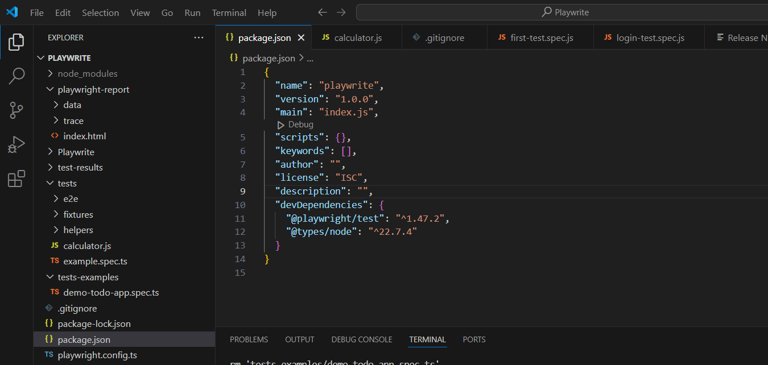  
  
I don’t know in which folder to add the.js   
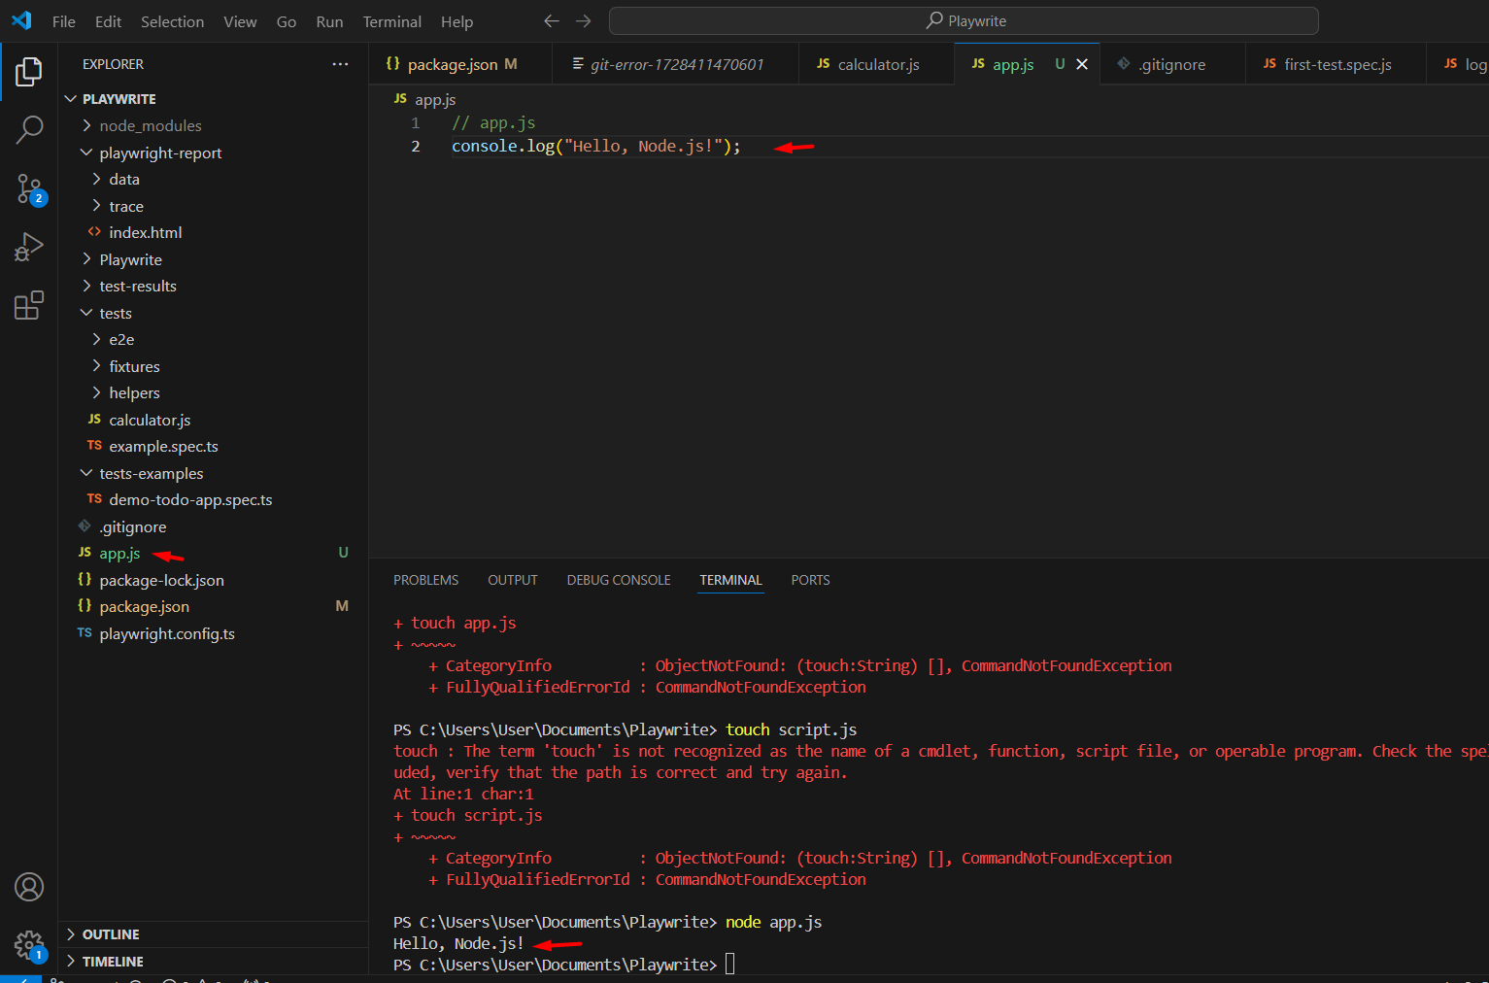  
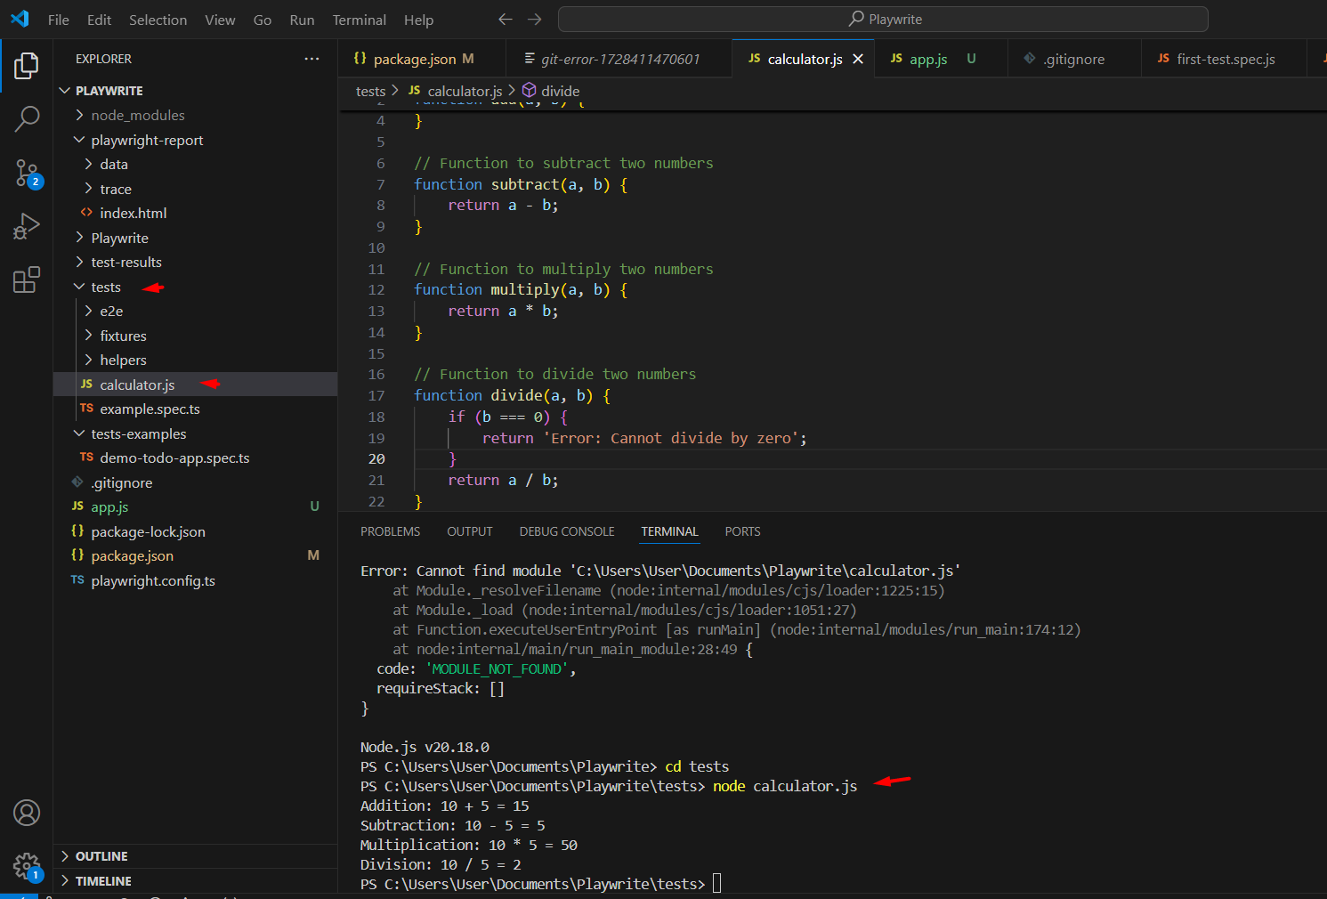

Task 5: Set up a new Playwright project on your machine. -OK

Task 6: Write and run your first test case. -OK  
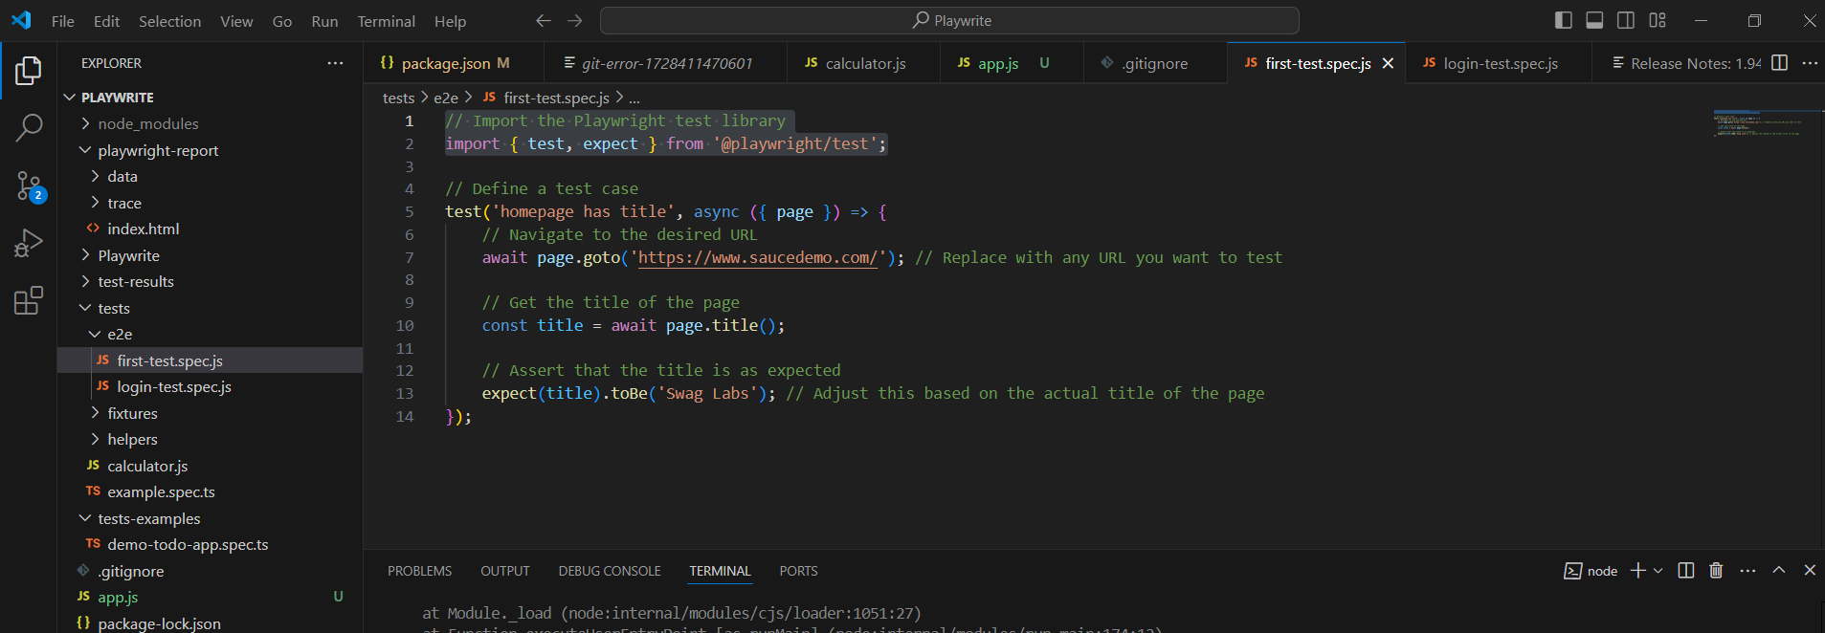  
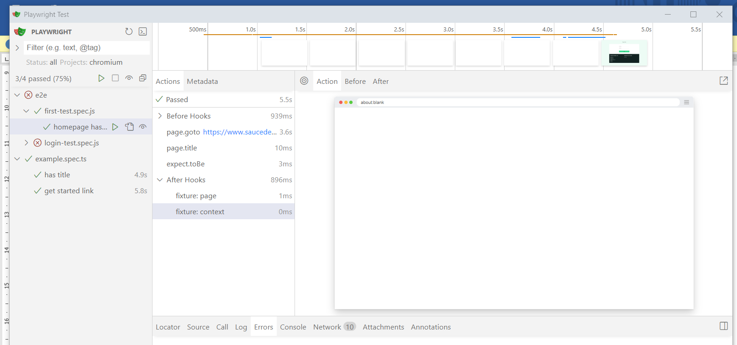  
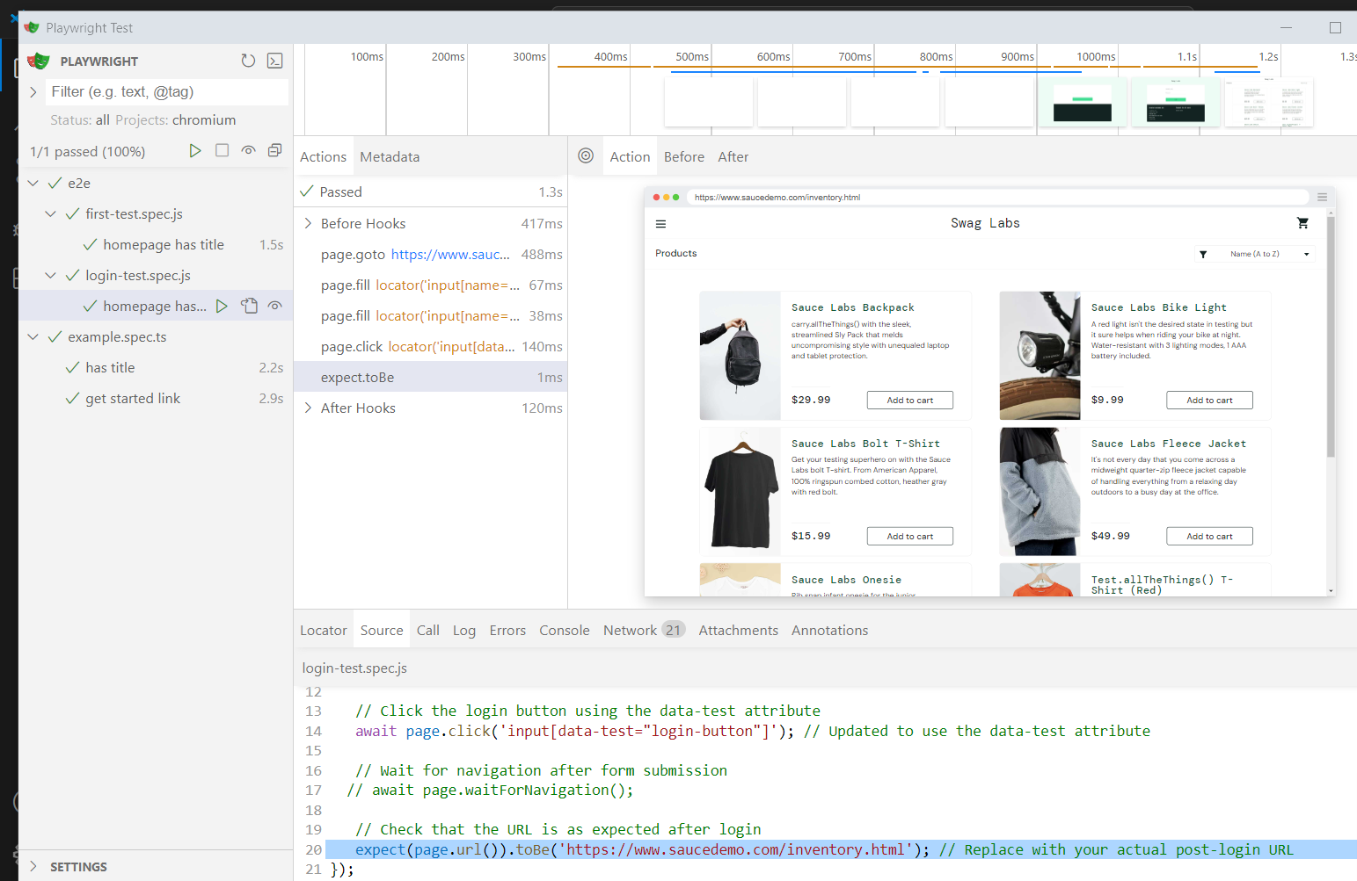

Task 7: Create a GitHub account if you don’t have one. -OK

Task 8: Create a new repository and push your Playwright project to GitHub. -OK

Task 9: Practice using Git commands by creating a new branch, making changes, committing those changes, and pushing them to the remote repository. Resolve any conflicts if they occur.   
I have an issue with this step and blocks me from continuing with work.  
  
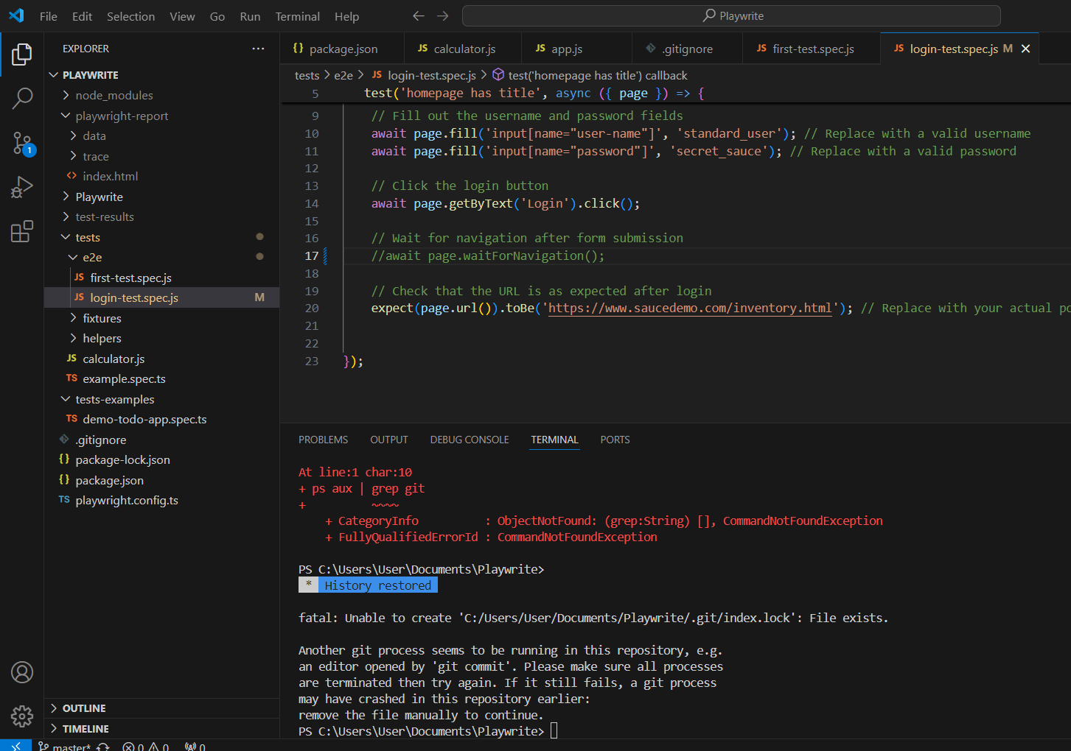

Task 10: Create a .gitignore file for your project and add common patterns to ignore unnecessary files and directories. –OK  
  
Please confirm that my .gitignore file is located correctly within the directory and review its content?

